December 24, 2024
11:00 pm

Prelude

Welcome Pastor Michelle

Lighting of the Christ Candle Tom Black

*Opening Song Joy To The World

*Song Hark The Herald Angels Sing

Pastoral Prayer Pastor Michelle

Scripture Luke 2:1-20 Rick Ellis
Message Amazed Pastor Beth

Communion Pastor Michelle

Thank you for placing your offering (and Connect Card)
in the baskets when you receive communion.

Lighting of the Candles

Benediction Pastor Beth
Postlude

*Please stand as you are able

Join us on Sunday, December 29
One Service at 10:00 AM

Christmas Pajamas and waffles fun for the kids with Niki, December 29 at 10:00 am in room 221

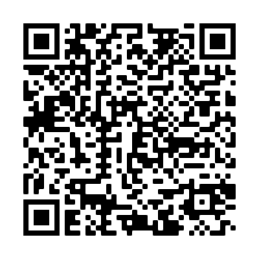

Please let us know you were here.
Scan this QR Code to fill out a
Connect Card.

Senior Pastor: Rev. Michelle Shrader
Executive Pastor: Rev. Beth Burton
Grace United Methodist Church
65 Needle Blvd, Merritt Island, FL 32953
Phone: 321-452-2420
Email: Info.gumc@gmail.com Website: gumcmi.com

