December 24, 2024
3:00 PM

Prelude “Jesus Child”

Welcome Pastor Beth
Lighting of the Christ Candle Bill & Cheryl York

Opening Hymn “Joy To The World”

Hymn “Hark The Herald Angels Sing”

Pastoral Prayer Pastor Beth

Special Music “What I Can, I Give Him”

Scripture Luke 2:1-20 Bonnie Venable
Christmas Message: “The Glory of God” Pastor Michelle

Communion Pastor Michelle

Lighting of the Candles

*Closing Hymn “Silent Night (Stille Nacht)”

Benediction Pastor Michelle

Postlude

*Please stand as you are able

Thank you for placing your offering (and Connect Card)
in the baskets when you receive communion.

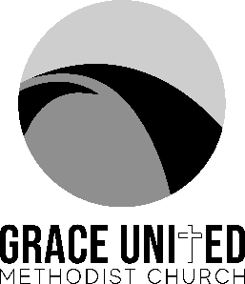

Join us for one service at 10:00 am on
Sunday, December 29, 2024.

******

Christmas Pajamas and waffle fun for the kids
with Niki, December 29 at 10:00 am in room 221

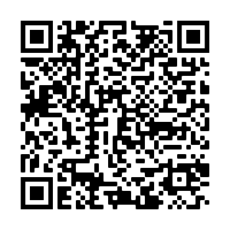

Please let us know you were here.
Scan this QR Code to fill out a
Connect Card.

Senior Pastor: Rev. Michelle Shrader
Executive Pastor: Rev. Beth Burton
Grace United Methodist Church
65 Needle Blvd, Merritt Island, FL 32953
Phone: 321-452-2420
Email: Info.gumc@gmail.com Website: gumcmi.com

